**Methods**

**Stuart-Landau Model**

To investigate the effects of different inputs on a system of coupled oscillators, we used the Stuart-Landau model (ref????):

where and are the two oscillators near Hopf-Andronov bifurcation (ref??). is the coupling parameter. For , the two oscillators oscillate synchronously with frequency whereas for , the system decays to a stable equilibrium. For all simulations, we set and to 0.05 and changed the which is the input to the system. We gave white, pink and brown noises (see below) scaled between input strengths 0.1, 1 and 10 to see their effect on synchronization. The differential equations were integrated with the Euler method with 0.1 second steps for 5 minutes.

**Simulation of Colored Noise**

We used MATLAB’s dsp.ColoredNoise function from DSP System Toolbox to generate different inputs. Briefly, gaussian white noise is colored by multiplication by an autoregressive model of order 63 in the frequency domain to filter it’s power spectrum according to the power law . Three different input scenarios were simulated: white noise (), pink noise () and brown noise ().

**Results**

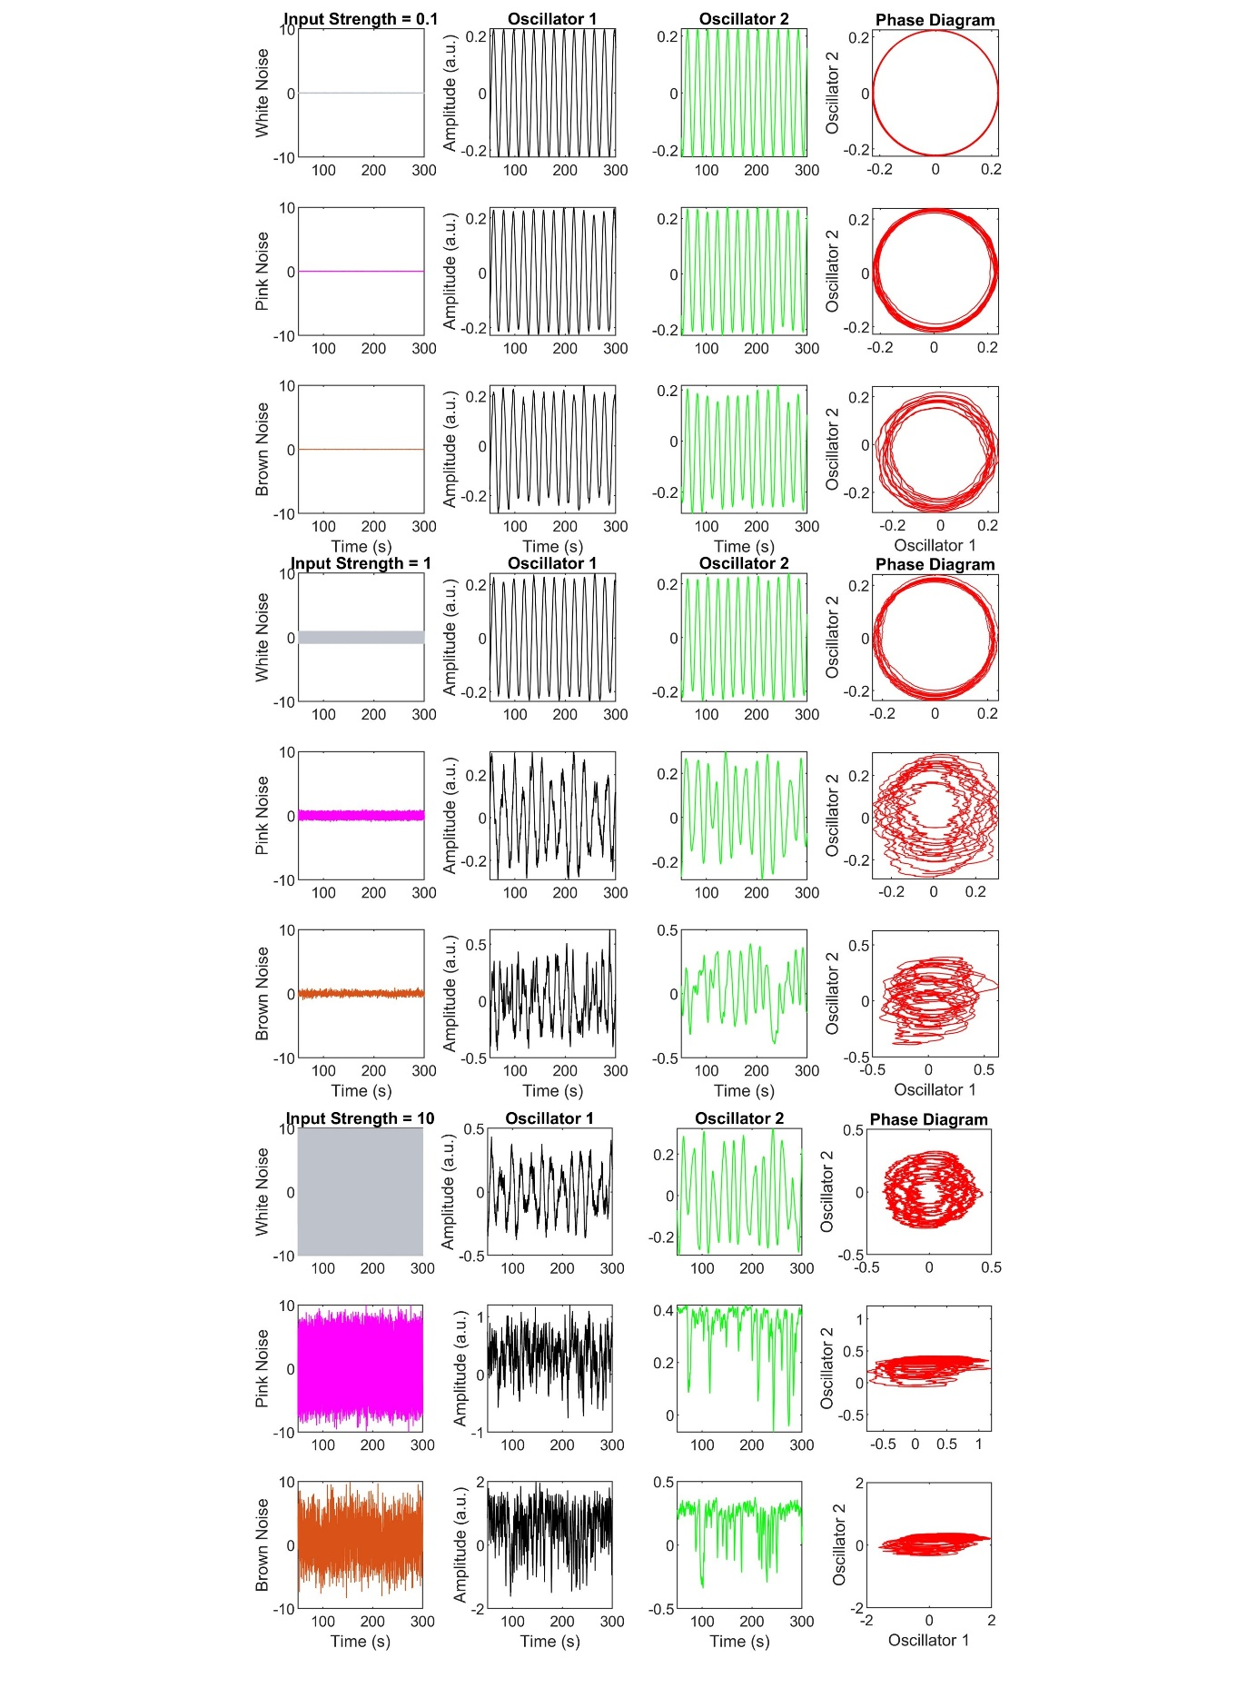

*Figure X.: The effect of different inputs on the Stuart-Landau model. We gave the model three different noise types with three different noise strengths each. As can be seen on the phase diagrams, input with a scale-free temporal structure can easily perturb a system even with low input strength whereas a white-noise input needs very high input strength to affect the system.*

We used Stuart-Landau model to investigate the effect of external perturbation on a system of coupled oscillators near criticality (Figure X). Even with low noise strength, the brown noise input with it’s high PLE value desynchronized the system even with a very low input strength. On the other hand, white noise needed very high input strength to make an effect. Pink noise stands between the tow signals in terms of both the PLE and needed input strength for perturbation.

**References**